PROJECT PROPOSAL |  | PROJECT GROUP NO:
DEPARTMENT:CSE |  | ACADAMIC YEAR:2017
A. Proposed Title of the Project
BUS RESERVATION SYSTEM

B. Introduction
- Introduction to the area of work:
Traveling is a large growing business across all countries. Bus reservation system deals with maintenance of records of details of each passenger. It also includes maintenance of information like schedule and details of each bus.
- Brief present day scenario with regard to the work area:
The focus of the project is to computerize travelling company to manage data, so that all the transactions become fast and there should not be any error in transaction like calculation mistake, bill generation and other things. It replaces all the paper work. It keeps records of all bills also, giving to ensure 100% successful implementation of the computerized Bus Reservation System.
We observed the working of the Bus Reservation System and after going through it, we get to know that there are many operations, which they have to do manually. It takes a lot of time and causing many errors while data entry. Due to this, sometimes a lot of problems occur and they were facing many disputes with customers.
- Motivation to the project work:
To solve the above problem, and further maintaining records of passenger details, seat availability, price per seat, bill generation and other things, we are offering this proposal of computerized reservation system.

C. Literature Review
- Recent developments in the work area:
The system is very simple in design and to implement. The system requires very low system resources and system will work in almost all configurations. It has got following features:
- Needs a lot of working staff and extra attention on all records.
- Enter data accuracy.
- Records are efficiently maintained by DBMS.
- DBMS also provides security for the information.
- Any person across the world, having internet can access this service
- Availability of seats can be enquired very easily.
- Passengers can also cancel their tickets easily.
- Minimum time needed for the various processing.
- Better service.
- Minimum time required.
- This would help the corporation prepare and organize its schedules more efficiently on the basis of traffic demand.
- Brief background theory:
- Existing system is totally on book and thus a great amount of manual work has to be done. The amount of manual work increases exponentially with increase in services.
- Needs a lot of working staff and extra attention on all the records.
- In existing system, there are various problems like keeping records of items, seats available, prices of per/seat and fixing bill generation on each bill.
- Finding out details regarding any information is very difficult, as the user has to go through all the books manually.
- Major problem was lack of security.
- Literature Survey:
In order to build the system, all the processes in the business should be studied. System study helps us under the problem and needs of the application. System study aims at establishing requests for the system to be acquired, development and installed. It involves studying and analyzing the ways of an organization currently processing the data to produced information.
Analyzing the problem thoroughly forms the vital part of the system study. In system analysis, prevailing situation of problem is carefully examined by breaking them into sub problems. Problematic areas are identified and information is collected.

D. Objectives
- Main work objective:
- Objective of the software is to computerize any traveling company to manage data, so that all the transactions become fast and there should not be any error in transactions like calculation mistake, bill generation and other things. It replaces all the paper work.
- It keeps records of all the bills also, given to the customers, so that user could update his daily accounts, almost care and back-up procedures must be established to ensure 100% successful implementation of the computerized Bus Reservation System.
- Practically: The system is quite stable and can be operated by the people with average intelligence.
- Efficiency: We tried to involve accuracy, timeliness and comprehensiveness of the system output.
- Cost: It desirable to aim for the system with minimum cost subject to the condition that it must satisfy the entire requirement.

E. Requirement Details
1. Hardware | - PC Pentium IV with 2.6 GHZ processor.  - Color monitor.  - Keyboard.  - 40 GB Hard Disk or above.  - 256 MB RAM or above.  - Intel Mother Board.
2. Software | - Operating System: Windows XP  - Front end: HTML  - MS-Office tools: MS-Word, Excel, PowerPoint.  - Backend: SQL, java, JSP
3. Skill sets | - Priority scheduling  It is a method of scheduling processes based on priority. In this method, the schedule chooses the tasks to the priority.
F. Figure(s)/Drawing(s)

SCHEMA DAIGRAM:

PASSENGER
PNO | PNAME | PPHNO | BUSROUTENAME | AGE | SEX | ADHARNO

BUS
BUSNO | BUSROUTENAME | SEAT | ARRTIME | DPTRTIME | COST

OWNER
OWNERNO | OWNERNAME | OWNERPHNO | BUSNO

AGENT
ANO | ANAME | APHNO | BUSNO | OWNERNO

ROUTE
ROUTEID | SOURCE | DESTINATION | BUSROUTENO | ANO

SEAT
ENTITY-RELATIONSHIP MODEL:
Arrtime

PPHNO
BUSRN
Dptrtime
PNAME
PNO
BUSRN
BUSNO
COST

AGE
Travels
BUS
PASSENGER

SEX

Adharno

owns
AGENT
Takes
Handles
Collects

ANO
ROUTE
OWNER

Anam
RID
ANO
ownerno
APNO
Ono
Busno
SRC
Busrn
busno
OPN
DST
ON

G. Methodology
System design is the process of planning a new system or replace or complement an existing system. But before this planning can be done, we must thoroughly understand the existing system and determine how computers can best be used to make its operation more effective. To obtain information about the current system and determine the requirements of the new system, study of the current system has been carried out.
System analysis, then is the process of gathering and interpreting facts, diagnosing problems and using the information to recommend improvement to the system.
In brief, we can say that analysis specifies what the system should do. Design specifies how the system should do. By using this, we can reserve tickets from any part of the world, through telephone lines, mobiles, via internet. Customer can check availability of bus and reserve selective seats. The project provides and checks all sort of constraints so that the user can give only the useful data and thus validation can be done in a useful way.
List of Entities and Attributes
- PASSENGER:PNO,PNAME,PPHNO,BUSROUTENAME,AGE,SEX,ADHARNO
- BUS:BUSNO,BUSROUTENO,SEAT,ARRTIME,DPTRTIME,COST
- OWNER:OWNERNO,OWNERNAME,OWNERPHNO,BUSNO
- AGENT:ANO,ANAME,APHNO,BUSNO,OWNERNO
- ROUTE:ROUTEID,SOURCE,DESTINATION,BUSROUTENO,ANO
- It ensures data accuracy.
- Records are effectively maintained by DBMS.
- DBMS provides security for the information stored.
- Any person across the world having the internet can access this service. Passengers can enquire for the availability of seats and cancel their tickets easily.
- Provides better service with minimum time requirement. It helps the cooperation to prepare and organize its schedules more efficiently on basis of the traffic demand.
H. Flowchart (Plan of Action)
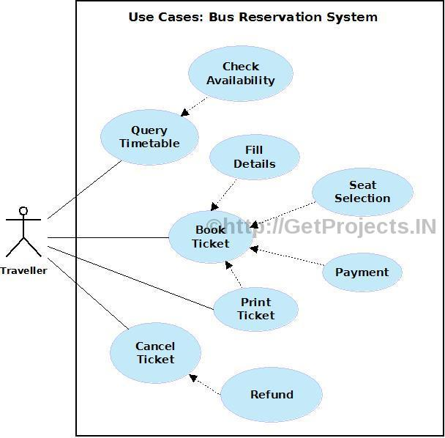
I. Expected Outcome of the project
This project is designed to meet the requirements of a bus reservation system. It has been developed in HTML and database has been built in SQL only, keeping in mind the specification of the system.
This application can be used by any bus operator to book the tickets. So throughout the country this application is used full for all the bus operators.
By using this application, the company can provide reservation services and information to their customers without the limitation of office hours or manpower. It not only lets customer’s book trips around the clock from any location with an internet connection, but it is also designed for use by the company to internally manage their business processes; minimizing human errors and overcoming difficulties and problems that arose in the previous system.
J. References
https://www.scribd.com/doc/23190984/Bus-Reservation-System-in-Dbms
http://shivajivarma.com/project/bus-reservation-system/
K. Project Batch members
S.No. | USN | Name |  | Signature with date
1. | 4MW15CS059 | NOOTANA GOVIND HEBBAR
2. | 4MW15CS063 | POOJASHREE.B.SHETTY
L. Accepted/Rejected:

